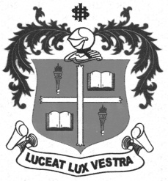
LOYOLA COLLEGE (AUTONOMOUS), CHENNAI – 600 034
B.A. DEGREE EXAMINATION – HISTORY
FIFTH SEMESTER – APRIL 2012

HT 5403 - WESTERN POLITICAL THOUGHT

Date : 30-04-2012 Dept. No. Max. : 100 Marks
Time : 1:00 - 4:00
PART-A

Answer any ten of the following in not than ten lines each:
(10X2=20)
- Philosopher-King
- Communism of Wives
- Social Justice
- Aristocracy
- Oligarchy
- Education Theory of Aristotle
- Idea of Liberty
- Concept of Secularism
- General Will
- Rousseau’s Ideas on ‘Sovereignty’
- Social Revolution
- Communist Manifesto
PART-B
Answer any four of the following in two pages each:
(4X10=40)
- Sketch the aims and ideals of education of Plato.
- Bring out Plato’s Justice and its characteristic features.
- Criticize the theory of Ideal State of Aristotle.
- Analyze the concept of Class Struggle of Karl Marx.
- Evaluate the State of Nature of Rousseau.
- Examine the theory of ‘Social Contract’ of Thomas Hobbes.

PART-C

Answer any two of the following in four pages each:
(2X20=40)
- Describe the theory of Ideal State of Plato.
- Compare the Social Contract of Rousseau with Thomas Hobbes’.
- Explain the various causes and preventives of revolution identified by Aristotle.

22.Narrate the contributions of Plato and Karl Marx to Western Political Thought.

